Educational Focused Incentives
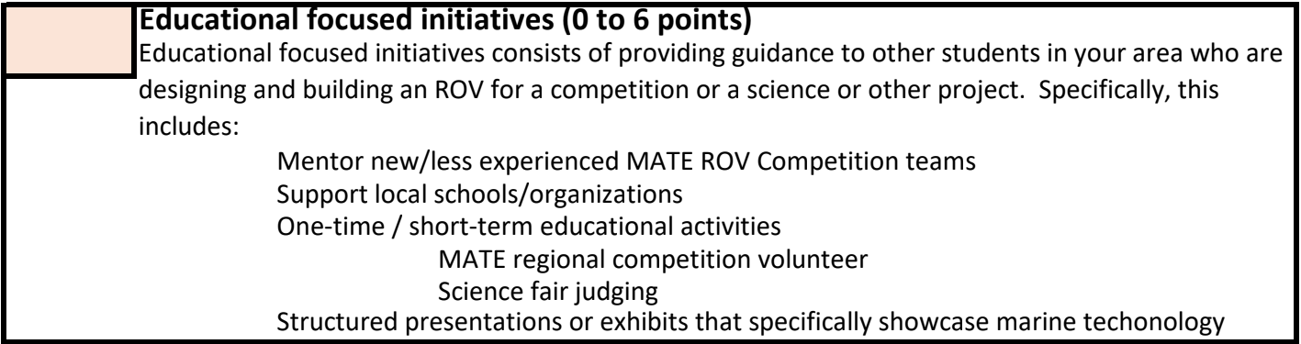
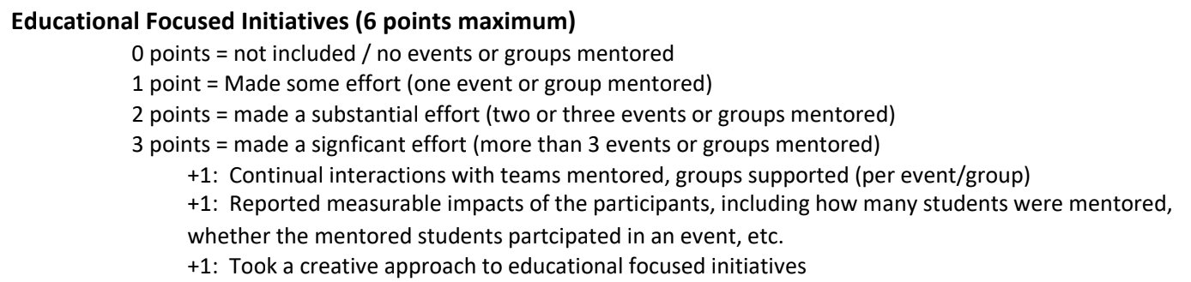
- Multi-mentor zoom meetings
  - Get at least 4 teams to attend a minimum of 3 zoom meetings to mentor teams on general engineering concepts relative to mate-rov
    - This gets the maximum 3 points for general incentives and the +1 for continual interactions
  - We could also hold review sessions with each individual team (depending on amount of teams we get) to help them generate new ideas and review idea concepts
    - Would need a minimum collaboration of 3 people per zoom meeting + more (1 per sub group?) to review proposal solutions
      - Basically just doing what Garrett and others did for our proposal from SPIRIT for some teams
- High-School involvement
  - Go to the local TAMU feeder highschool and involve ourselves with science fair judging, MATE regional competition volunteering, etc.
    - We would need to do at least 3 events and do multiple for the same highschool
    - Lowkey kinda a fallback plan if the above doesn’t work

Engaging the Community
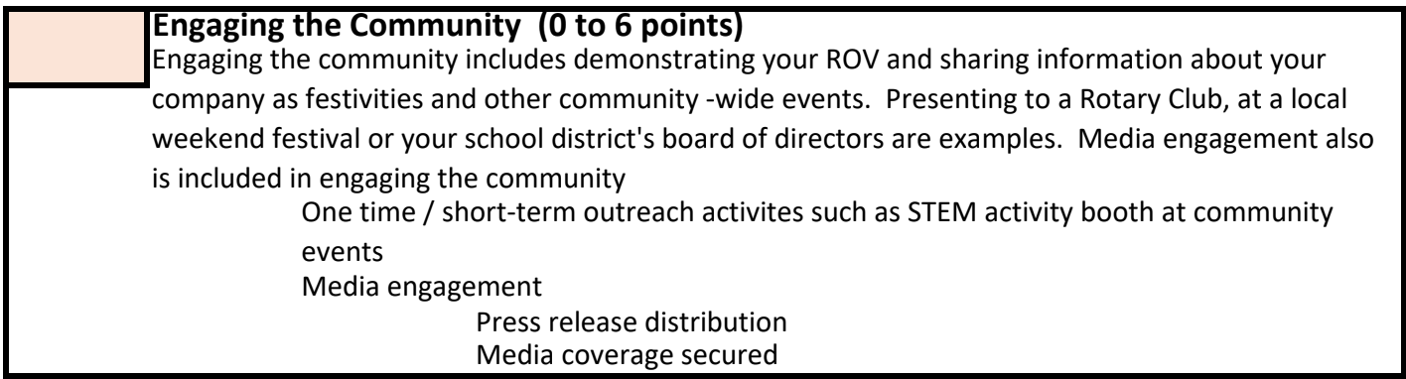
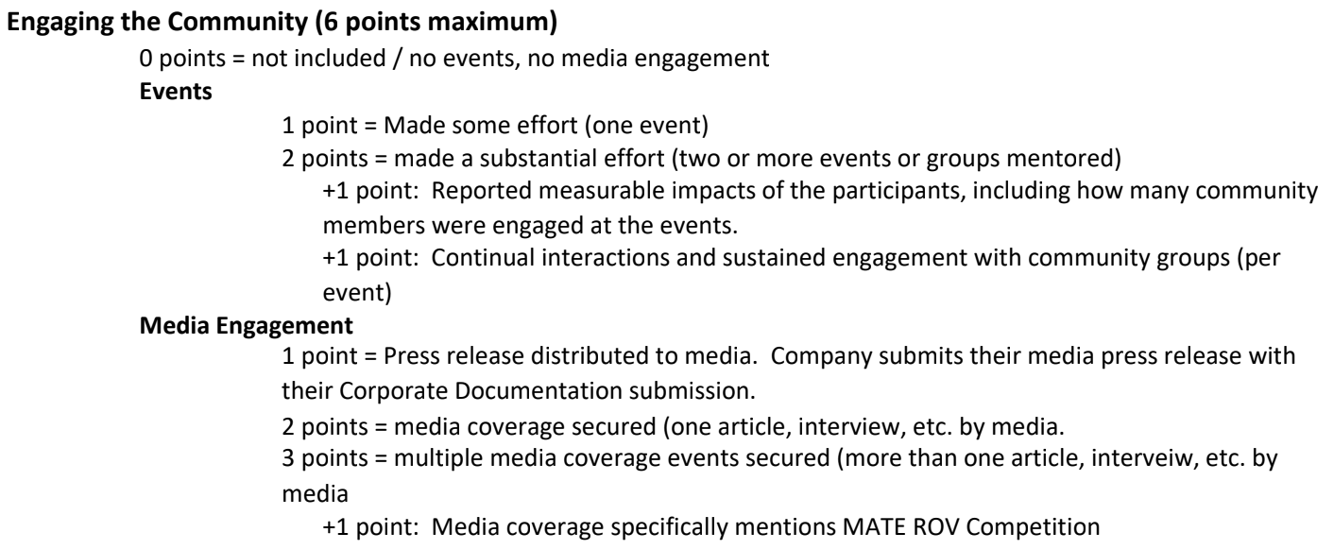
- Events
  - Envision Conference Invite
    - Booth that runs for approximately 30 minutes that is meant to engage groups of elementary schoolers visiting for several minutes at a time.
  - Table in front of zach, MSC to people once bot designs are finished
    - Bring physical prototype w/ us
    - Design some sort of flier to give to the people, google form to show interest in next year if people want to apply?
    - Count the total number of people we talk to per tabling day
  - Maybe hold a ThinkTank presentation covering our design / program challenges to freshmen? Ask for access to a meeting room?
    - Could swing as ThinkTank outreach overall - doesn’t have to just be about mate rov, could collaborate with other teams
- Media Engagement
  - Tamu press papers distributed to dorms – could get a small article for this
  - Instagram showing members, design progress, etc.
  - Reach out to local news for interviews? Could talk about comm. Service (see other sections)
  - Talk to TAMU news / journalism orgs to get interviews
  - Just spam the phrase “MATE ROV Competition” so it gets added in everything
Environmental Impact
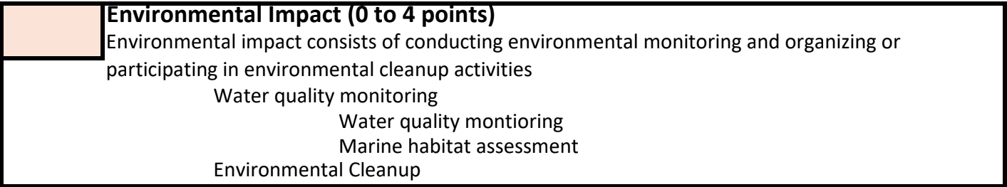
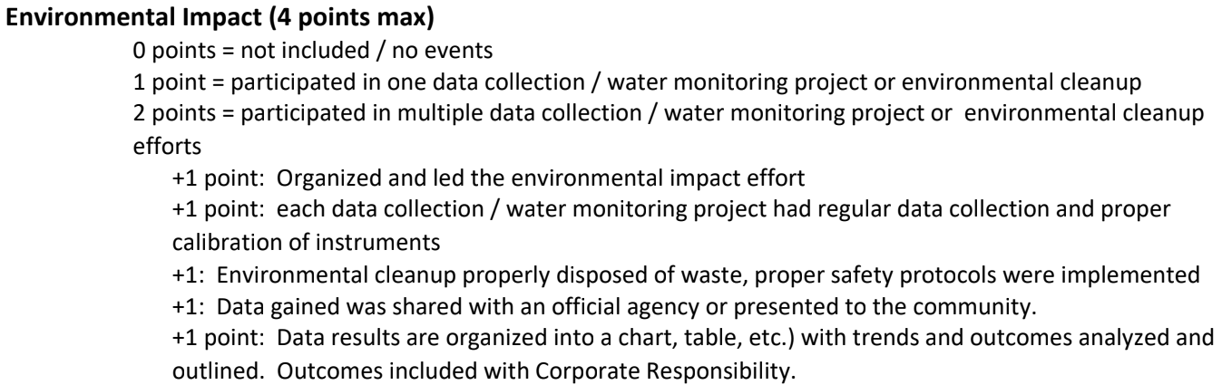
- Beach cleanup
  - Lake Galveston, Gulf, etc.
    - Could reach out to city mayor / governing body to organize the lake cleanup? Then market to TAMU students outside of ThinkTank for extra volunteers – extra point 1
      - BIG EVENT?
    - Track how much trash each team is picking up
    - Possible incentives for the team that picks up the most trash? And for the single person that does?
    - Keep track of cleanup data and statistics for extra points 2, 3, 5.
    - If we do it before presenting stuff to students, we could show our data for service (“we rid the beach of x pounds of trash over y days”), extra point 4
If you have any more ideas for service lmk, these guidelines could go for any comm. service project

Knowledge Sharing
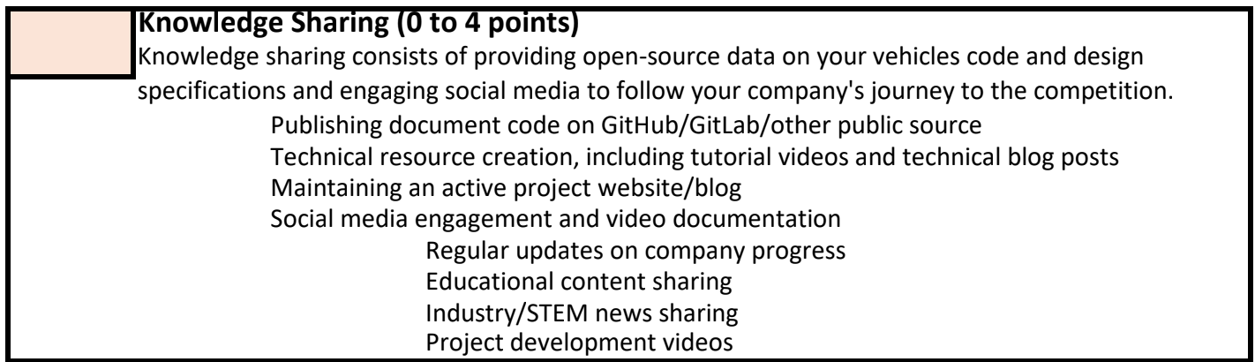
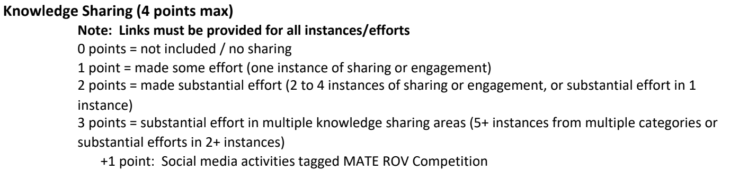
- Could record zoom meetings and post to youtube
- Post all code to github
- Project website – if no one wants to commit time to this, I know someone who might do it for us for resume stuff
- Social media engagement
  - Instagram posting weekly progress updates on progress for each team
    - Idea: each subgroup keeps a notebook that they fill with literally any idea they come up with, good or bad. Only write on left page, right page you come back to and annotate w/ commentary
      - Good to show design development over time, mistakes, and documentation
      - Would only really be useful for physical teams; teams like gnc could still use for pseudocode / very high level documentation before putting in a tech. report
        - I totally did this for science fair back in highschool and I got a shit ton of praise from judges bc we had soooooooo much documentation. I seriously recommend it
  - Could talk to other orgs / TT teams about social media engagement

